Self Video Document

Kartik Velede

INFO8940

Edward Hartwig

Posted Date: November-20-2020

Due Date:December-12-2020

# Document Library Client Needs Analysis Report

## **Background:**

The main objective of this analysis report is to train the learners about the SharePoint Document Library. All the new learners have been asked to fill the survey report form to know about the leaners existing knowledge on Document Library. We decided to do some training modules for the new learners about the document library, how to navigate to document library ,creating document library in SharePoint site. A mini lesson on document library has already been given to leaners and feedback is taken for the following. Based on feedback we got positive response from the learners and most the learners felt that mini lesson was very beneficial to them and feedback will be helpful for knowing the learner choice of learning and improvisation in coming training sessions.

## **Survey Report:**

Question one, when asked about the registration for office 365 90% of the learners said yes and 10% said no.

Question two ,when asked about the document library experience 80% of the learners said that they no idea about the document and remaining learners said they have basic knowledge about it.

Question three, when asked about meaning of document no learners was able to answer the question appropriately.

Question four about the features in document library ,below is the result showing the percentage of users having idea about it

Co-Authoring – 90%

Offline Syncing – 75%

Metadata – 80%

Views – 30%

Version History – 50%

Question five when asked about the creation of document library ,all the learners said No.

Question Six when asked about creating view in document library ,all the learners said No.

Question seven is about the knowing the learners in learning check in or check out files in document library ,all the learners rated 5.

Question eight about the types of libraries, below is the result showing the percentage of learners having idea about it.

Document Library- 50%

Form Library- 10%

Picture Library-10%

Record Library-10%

Report Library-10%

Wiki-Page Library-10%

Question nine when asked about document library utilization ,all the learners have chosen neutral option

Question ten when asked about the additional things all the learners said that they are happy with present training manual.

Question eleven when asked about additional session 60 percent leaners said and remaining said no.

## **Findings**

Based on the survey report what I found is most of the leaners have minimum or no idea about document library. Most of users are unaware about creating the document library. All the users are very much interested in learning about the document library and their features. Overall, the response from learners seems to be positive.

## **Recommendations**

By analysing the survey report I have decided that the following topic needs a lot of attention.

1. Definition of Document library and benefits of it.
2. Creating the Document Library
3. Creating views for the document library.

The topics that will included in training session is

1. Introduction
2. Creating document library
3. Creating views for files
4. Sharing of documents
5. Features of document library
6. Types of libraries
7. Document retention policies.

# Document Library Client Needs Survey

Below is the link to survey form

<https://forms.office.com/Pages/ResponsePage.aspx?id=OjndTYrpBESEH8S-zdklpSC3-6VD9-5JtqwkuJFenCpUMlFGRE1UMUxPR1dRVUJaNlBGWUVDSjE4Ui4u>

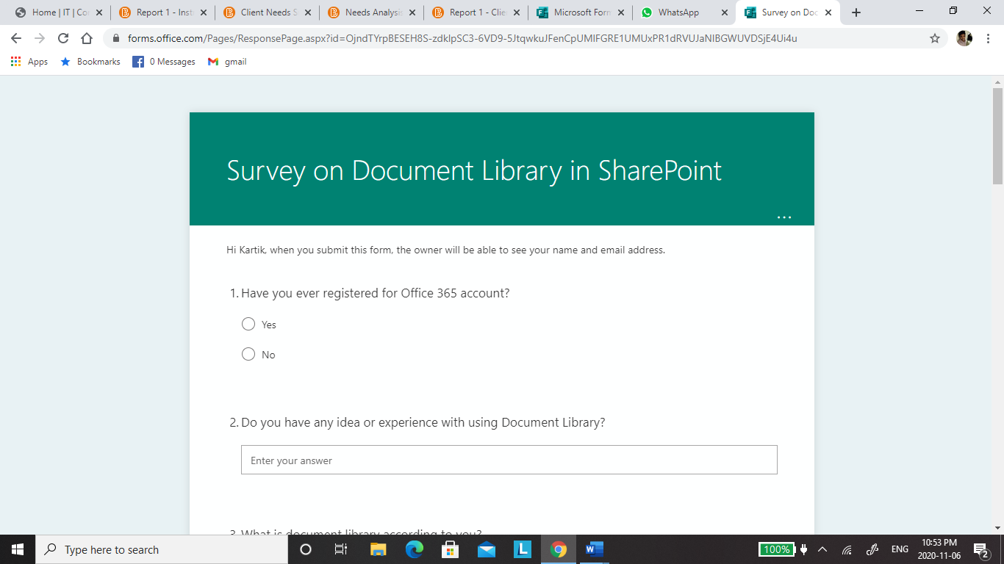

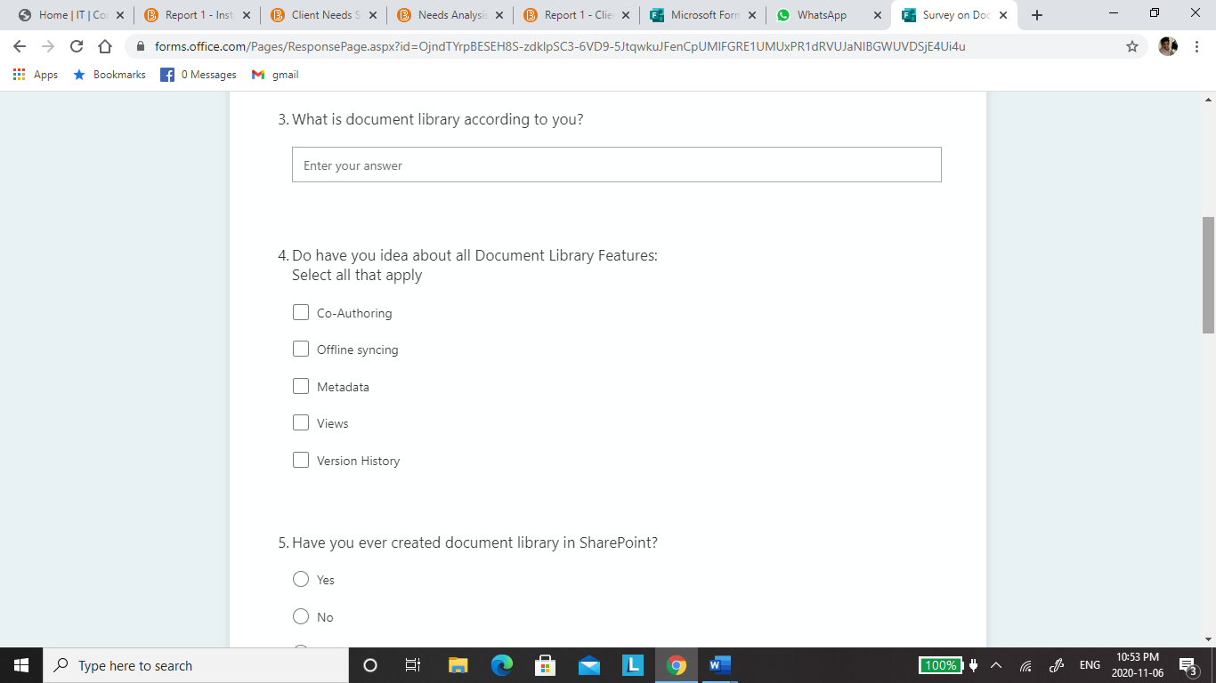

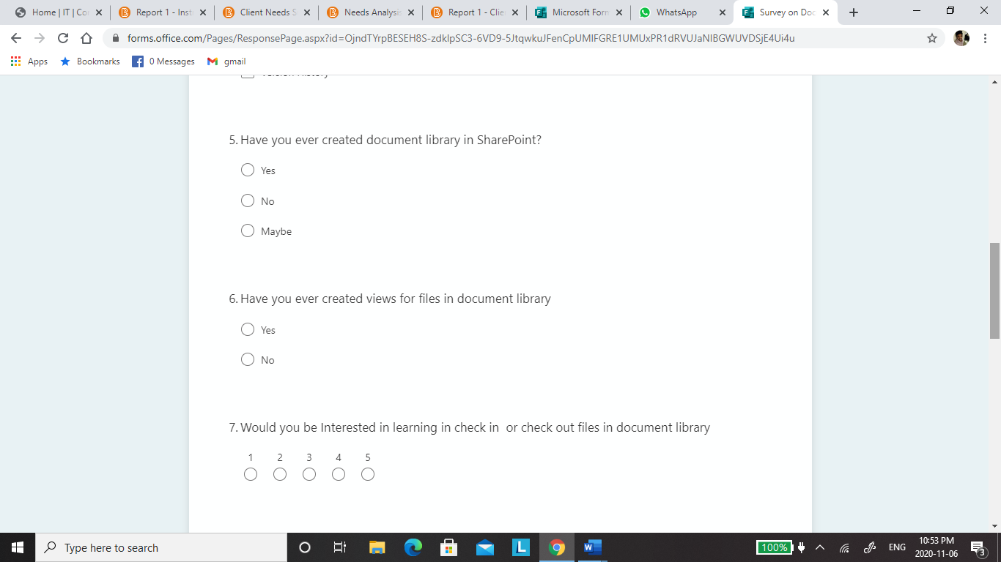

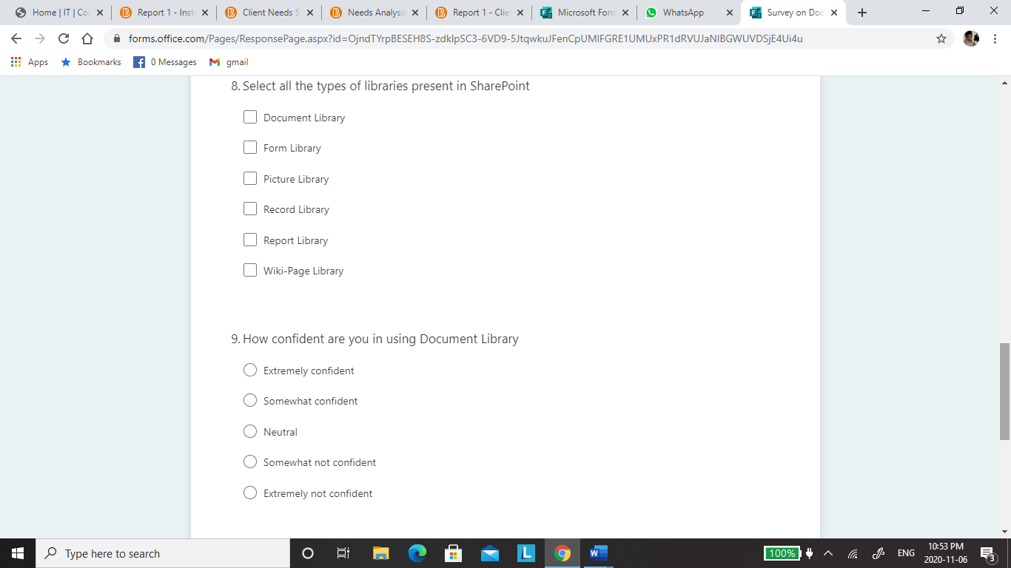

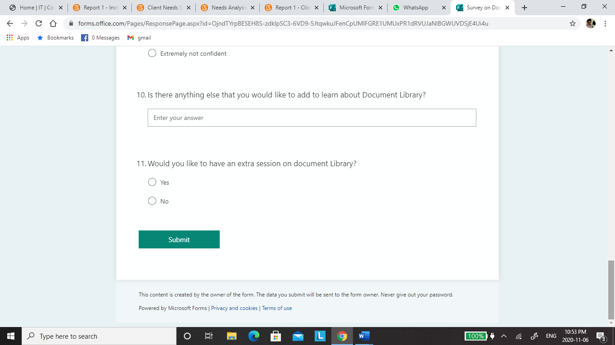

# References

<https://www.avepoint.com/blog/sharepoint-hybrid/sharepoint-document-libraries/>